

Adaptive agribulk terminal planning in light of an uncertain future

Terminal Design Optimization

[Cover date: 22 Oktober 2018]



This page will be removed

Terminal Design Optimization

Wijnand IJzermans

Index

Executive Summary 3

1 Introduction 5

1.1 Background 5

1.2 Problem Statement 5

1.3 Research Objective 5

1.4 Thesis Outline 5

The Trade in Agricultural Commodities 7

2 Agricultural Commodities 8

2.1 Commodity scope within this thesis 11

2.2 Global trends 11

2.3 The agricultural Supply Chain 12

3 Agribulk Terminal Characteristics 14

3.1 Vessel characteristics 14

3.2 Terminal seaside interface 14

3.3 Terminal storage 23

3.4 Terminal landside interface 24

3.5 Environmental aspects 25

3.6 Terminal example 25

Optimizing Terminal Design Strategy 26

4 Literature Study Into Terminal Modelling 27

4.1 Existing terminal models 27

4.2 Simulating terminal seaside interface 27

4.3 Simulating terminal superstructure 27

4.4 Simulating terminal landside interface 27

5 Optimization Through Simulation 32

5.1 Modelling objective 32

5.2 Key performance indicators 32

5.3 Model structure 32

5.4 Triggering investments within the simulation 32

5.5 Significant factors for terminal design 33

5.6 Increasing terminal flexibility 33

6 Making Economic Projections 34

6.1 Traffic scenario’s 34

6.2 Traffic forcasting 35

6.3 Application within the model 37

7 Reactive simulation approach 39

7.1 Applied economic projection methods 39

7.2 Terminal seaside interface 39

7.3 Terminal superstructure 39

7.4 Terminal landside interface 39

8 Predictive simulation approach 40

8.1 Applied economic projection methods 40

8.2 Terminal seaside interface 40

8.3 Terminal superstructure 40

8.4 Terminal landside interface 40

9 Results 42

9.1 Reactive approach 42

9.2 Predictive approach 42

Case Study 43

10 Agribulk Import Terminal in Africa 44

10.1 Why Africa? 44

10.2 Terminal location 44

10.3 Applied economic projections 44

10.4 Resulting terminal 44

10.5 Conclusions 44

Conclusions and Recommendations 46

11 Conclusions 47

11.1 Research into investment triggers 47

11.2 The added value of integrating forcasting into the design process 47

12 Recommendations 49

12.1 Investment triggers 49

12.2 Forcasting mechanism 49

1 Appendix – Model Validation I

1.1 Investment triggers I

2 Bibliography I

# Executive Summary

‘Economic masterplanning is designing a port that is feasible. In this research however, we will focus on scale of individual terminals as a result of time constraint. ‘

‘There’s a economist making traffic projections, there is a port engineering team that translates that projection into a port masterplan and then in the end the economist re-evaluated the masterplan and analyses its feasibility. This results in a very coarse feedback mechanism in which the final economic analysis may require the port engineers to redo their initial design, leading to an increase in design costs. Integrating economic analysis into the design process sets out to facilitate this process by supporting port engineers through visualizing the economic impact of their design assumnptions. **Check introduction to Cornelis’ introduction.**

Economics and port planning are intertwined as they go hand in hand in the following three design stages:

* Cargo projections: expected throughput columes, tarigg levels and resulting revenues
* Port design: port engineer prepares design which is then translated into capital expenditures (capex) and operational expenditures (opex)
* Financial evaluation: economists analyse the financial feasibility of the project and take into account inflation rates, depreciation levels, finance structure and tax payments.
* Economic evaluation: economists analyse the project feasibility from an economic perspective, which includes the the (non)desirable effects from a societal point of view. Required for sibsidies and grants
* Project funding: financial expert investigates the options to fund the project by creating conditions in which the returns and risk level of the project are acceptable to the lender, unlocking the capital required to initiate the project

This research focusses on how cargo projections can be combined with capex and opex estimates in order to quantify the added value of flexibility within the design and optimize the terminal’s design for financial feasibility

“The further you look ahead, the less you see. You can still look far ahead, but then you have have peace with the fact that this results in a lower level of detail. This is an inevitable tradeoff. ”

(Wiegmans & Schott, 2017)

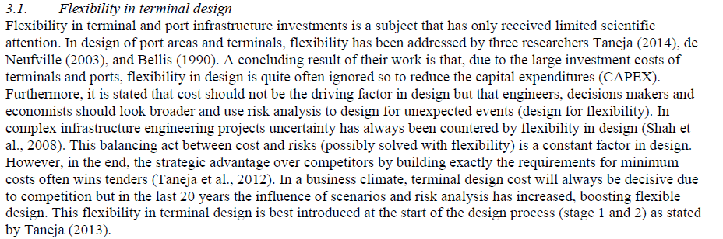



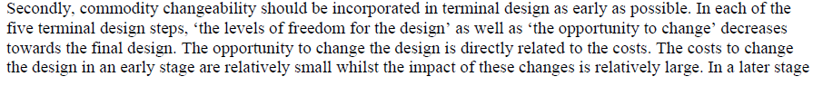

## Introduction

#### Background

Many existing simulation models (Dragović, Tzannatos, & Park, 2017).

Figure 0.1

Table 1

#### Problem Statement

#### Research Objective

#### Thesis Outline



# The Trade in Agricultural Commodities

## Agricultural Commodities

Global cereal demand is growing gradually at 1.8% per year, while consumption of oilseeds - for animal feed, biofuels and processed foods - is soaring (UN COMTRADE)

Brazil is a fast-growing consumer of food, energy and metals. Its per capita meat consumption rose from 28 to 82 kg between 2000 and 2010. As GDP increases, diets will shift, resulting in an increased demand for meat in emerging economies. Average meat consumption in China increased from 3.8 to 52.4 kg per capita between 1990 and 2002.

India’s resource consumtion is rising gast, with an expanding economy, large population and low rates of consumption per capita

With a population of over 240 million and relative low per capita consumption, Indonesia’s resource demand is set to grow significantly

Closing the yield gap in Sub-Saharan Africa would increase and diversify global production away from two major net-exporting regions in North and South America.

Biofuel subsidies have pushed up maize demand in the US

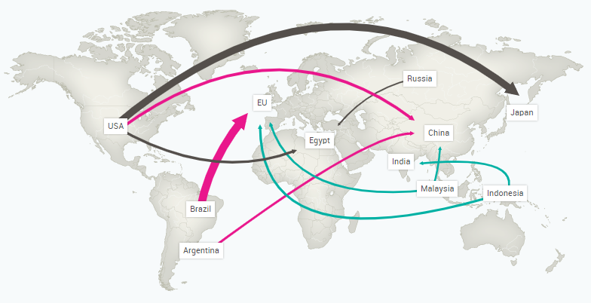

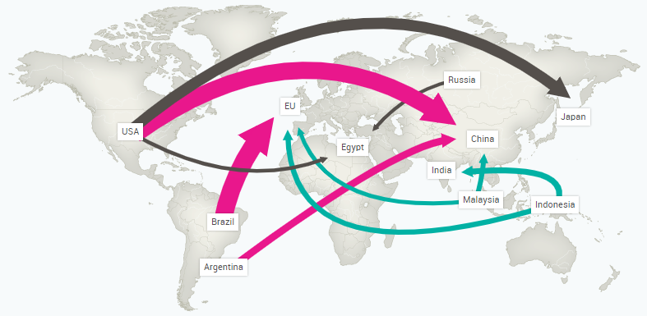

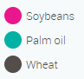

China is not pursuing self-sufficiency in soybeans and omports have grown rapidly – to geed anumals and build a strategic reserve. Brazil has emerged as the most important exporter. US export geowth is held back by policy support for maize ethanol

Production of agricultural commodities is concentrated, the three largest producers for 19 commodities account for 56% of total production. Four countries account for over 70% of global maize production. US, Brazil and Argentina produce 80% of global soybeans.

New producers are emerging in Eastern Europ and Sout America with Ukraine, Mexico and Brazil showing strong annual growth in wheat, amize and soybean production between 2000 and 2010:

Ukraine (5.1% annual growth of cereal production 28% annual growth of oil seed production)

Uruguay ( 45% annual growth of oil seed production)

Mexico (1.7% annual growth of cereal production )

Brazil (3.9% annual growth of cereal production )

Argentina (3.5% annual growth of cereal production )

With some of the most fertile agricultural land in the world, there is large potential for further yield improvement as on-going modernisation of the agricultural sector in Ukraine is ongoing with the help of foreign investmentment

Focus on agribulks. Why?

* Original focus on bauxite, but the market has been vertically integrated. The port has fallen under the same owner as the mine and has therefore become a node in the mine’s supply chain. This results in the ports drive to becoming economic is secondary to that of the mine.
* A conventional sector that has been around for a long time. However, conventionally resulted in relatively small scale ports, but this is rapidly changing due to the global demand of agriculture products due to population growth. And example is China, who is investing heavily in foreign producers, turning them into agriculture powerhouses. This boost in production goes hand in hand with the upscaling of port facilities.

#### Commodity scope within this thesis

Meals (soy-, barley etc.) are susceptible to moisture. Moisture increases angle of repose and increases commodity volumetric weight. In the model the lowest angle of repose (dry case) and a volumetric weight has been determined using average conditions (Bart-Plange, Dzisi, & Addo, 2011; Omega, 2015; University of Georgia, 2016; Wang, Chung, & Spillman, 1995)

|  |  |  |
| --- | --- | --- |
| Crop | Density [kg/m3] | Angle of repose |
| Barley | 660 | 28 |
| Cocoa | 560 | 27 |
| Corn – grains | 670 | 30 |
| Corn - meal | 670 | 30 |
| Hops | 560 | 30 |
| Malt – grains | 560 | 30 |
| Malt – meal | 640 | 30 |
| Rapeseed - grains | 620 | 29 |
| Sorghums - grains | 720 | 30 |
| Soybeans | 760 | 25 |
| Soy – meal | 560 | 30 |
| Sugar | 900 | 37 |
| Wheat - grains | 770 | 28 |

Global Trade Figures

The five major bulk solid cargoes handled worldwide are:

Volume (Mtpa in 2010)

Iron ore 984

Coal 904

Grain 343

Bauxite 64

Phosphate 23

(PIANC, 2014)

FAO databases

OEC databases

#### Global trends

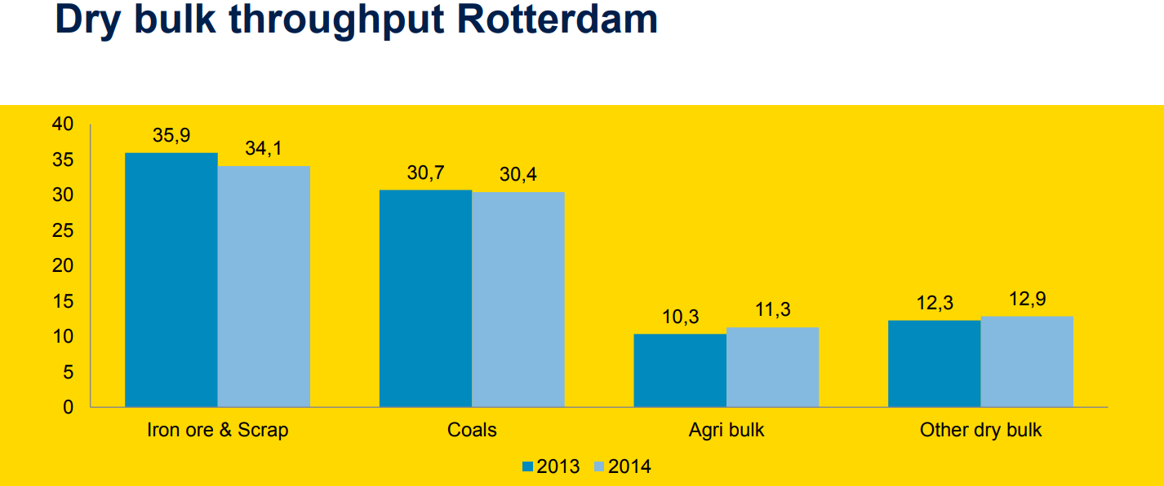

#### The agricultural Supply Chain

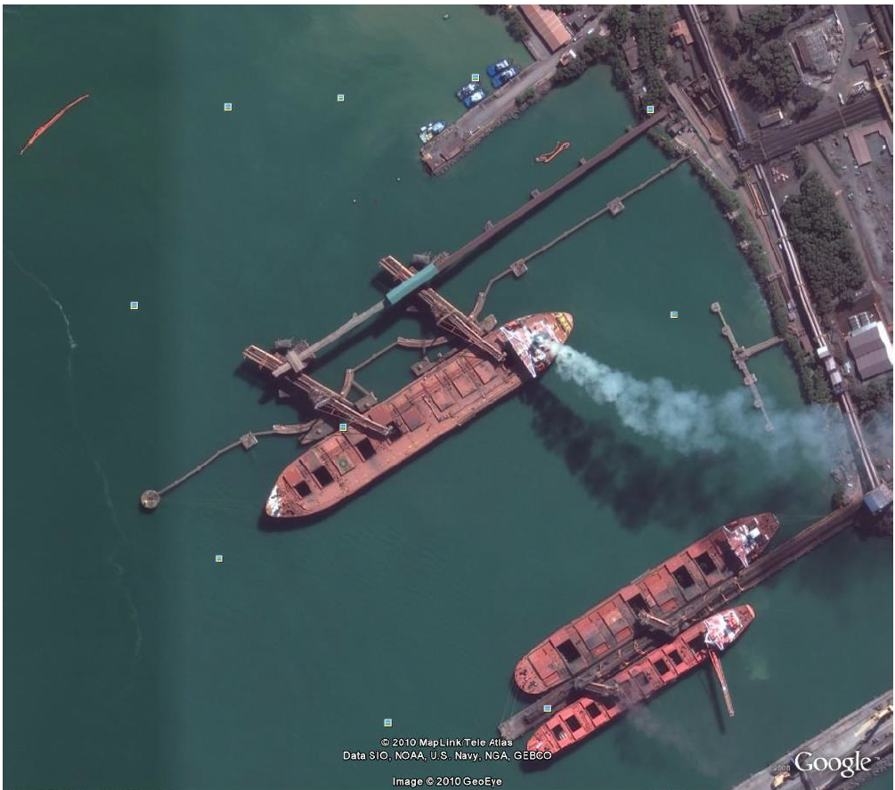

Figure 0.1: Loading of vessels in Tuberao, Brazil (Google Earth)

## Agribulk Terminal Characteristics

Introduction

Asdf

Asdfa

#### Vessel characteristics

#### Terminal seaside interface

* + 1. Ship Unloading Equipment

There is an array of equipment capable of unloading dry bulk vessels. Some do this in a continuous fashion, such as the chain conveyor, whereas cranes equipped with grabs unload vessels in a discontinuous manor (Ligteringen & Velsink, 2017). The following unloading systems fall within the scope of this research:

* + Cranes equipped with grabs (discontinuous)
  + Bucket elevators (continuous)
  + Vertical screw conveyors (continuous)

The capacity of a terminal’s unloading equipment often governs terminal productivity. For this reason all terminal components within the model are geared to that of the unloading facilitites (with storage facilities being the only exception). The capacity of a piece of unloading equipment can be subdivided into three categories (Verschoof, 2002):

|  |  |  |  |  |
| --- | --- | --- | --- | --- |
|  |  |  |  | Index |
| Peak capacity | - | *The peak capacity* relates to the optimal unloading rate at the beginning of an experienced crane operator’s shift, during which the cargo hold is full. This unloading rate will be the design capacity to which other terminal components within the model will be geared. |  | 2.5 |
| Rated capacity | - | *The rated capacity* is also known as the *free-digging rate* and is based on the cycle time of a full bucket/grab from the digging point inside the vessel’s hold to the hopper on the quay and back. |  | 2.0 |
| Effective capacity | - | The effective capacity resembles the average hourly rate of unloading the entire cargo of a vessel. This includes trimming, cleaning and switching holds. For continuous unloaders, the efficiency factor is slightly higher as less cleaning operations are required and the achievable rates of discharge are less influenced by the amount of cargo remaining in the hold (PIANC, 2014). The effective capacity is multiplied by the yearly operational hours of the port, taking into account the allowable berth occupancy rate, in order to compute the berth’s annual capacity. |  | 0.9 – 1.4 |

The following figure visualizes the three stages within the unloading process of a dry bulk vessel filled with coal, using a gantry grab with a free-digging rate of 1300 t/h. In this case the effective capacity of the crane is 650 t/h.

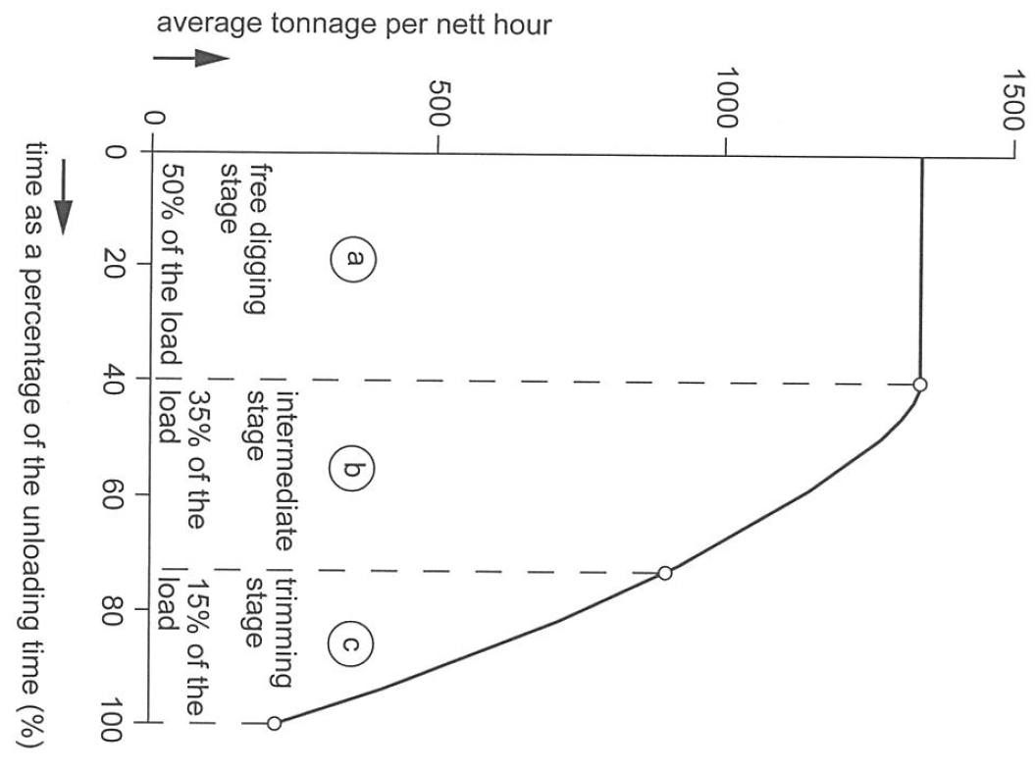

Figure 0.2: Various stages within the unloading procedure

* + - 1. Grab Cranes

Cranes equipped with grabs are the most commonly used method to unload dry bulk vessels for bulk cargo’s, as they can handle a wide range of commodities (PIANC, 2014). When handling free-flowing commodities such as agribulk, the traditional clamshell bucket has proven to be the most cost-effective grab mechanism (**see figure X**).

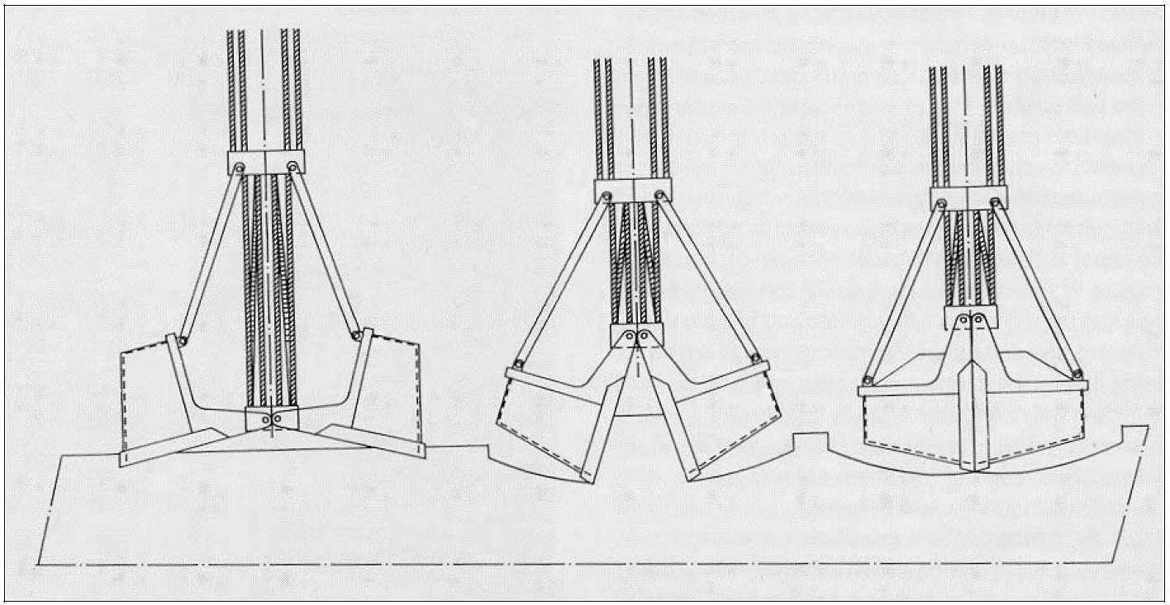

Figure 0.3: Clamshell mechanics (Miedema, 2006)

Grabs are used on gantry cranes, level-luffing cranes, radial cranes and mobile harbor cranes (UNCTAD, 1985). The unloading capacity of such a crane is based on two components:

* + The grab capacity of a crane
  + The speed at which the crane completes an unloading cycle

Consulting grab producers and analyzing the loadout of cranes on existing terminals has shown that there is a linear correlation between a crane’s *lifting capacity* [t] and the corresponding *grab load* [t], regardless of the type of crane or the type of commodity being handled (**see figure X**) (Nemag, 2018; Verstegen, 2018). The only exceptions are related to the handling of wood pellets due to their very low volumetric density (400 – 450 kg/m3). By removing the data regarding wood pellet terminals, the required lifting capacity of a crane, $C_{crane}$ [t], can be related to the required net grabbing capacity of a crane, $C_{grab}$ [t], through the following expression:

$$C_{crane}=1.404 C_{grab}+2.41$$

Figure 0.4: Empirical crane data

The speed at which cranes can complete an unloading cycle is largely dependent on the type of crane being used. The following sections elaborate on the four main types of cranes being used on terminals:

* + Gantry cranes
  + Level-huffing cranes
  + Radial cranes
  + Mobile harbour cranes
    - * 1. Gantry grabs

Gantry grabs allow the clamshell bucket to travel over an overhead boom and discharge the load in a dedicated hopper (see **figure x**), offering the fastest handling time of all the cranes that can be equipped with grabs. Large gantry grabs are normally semi-automated. The crane driver, sitting in a movable, but stationary cabin, digs in the grab with the help of the controllers. After having hoisted the grab up to a certain position, a knob is pushed which starts the automation. The grab automatically runs towards the hopper, opens, discharges the material, and automatically returns to the point where the crane driver started the automation. The crane driver then takes command again and lowers the grab further to fill it. Duty cycles of approximately 45 seconds can be achieved using such technology (Verschoof, 2002). However, as this only applies to a high-end selection of crane models (Ligteringen & Velsink, 2017), **the number of cycles per hour is set to 60 within the model**.

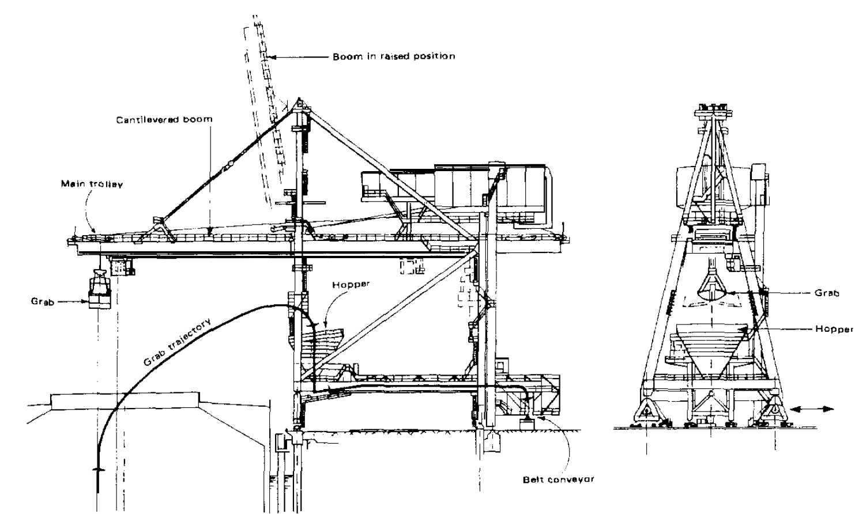

Figure 0.5: Gantry grab

* + - * 1. Level-huffing grabs

Level huffing grabs, sometimes referred to as kangaroo cranes, can keep the grab at a constant height while moving it towards the quay. The cargo is fed into a hopper that is fixed to the front of the crane, eliminating the need to rotate and increasing its handling rate **to 40 cycles an hour** (UNCTAD, 1985).

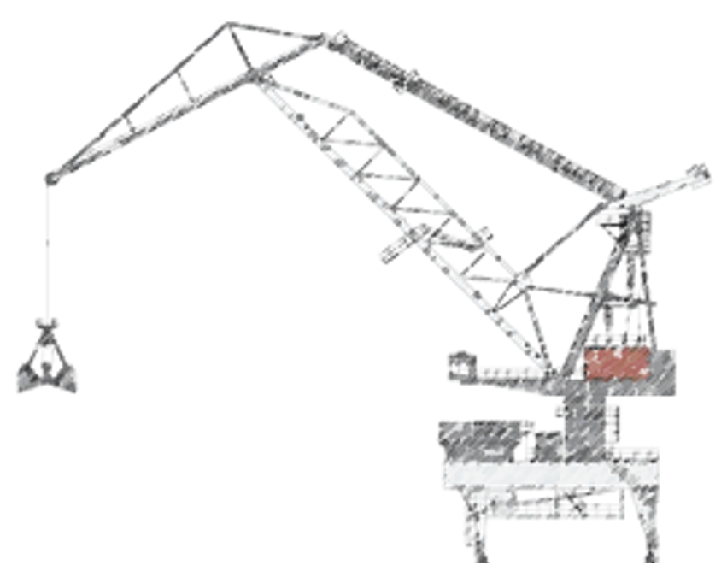

Figure 0.6: Level-huffing crane

* + - * 1. Radial Grabs

Radial grabs, or revolving grabbing cranes, are the most commonly used type of crane used for unloading. The crane lifts the material and discharges it into a hopper on the quay. Due to the the required rotating motion, the handling rate is a lot lower than level-huffing grabs **at 20 cycles an hour** (UNCTAD, 1985).

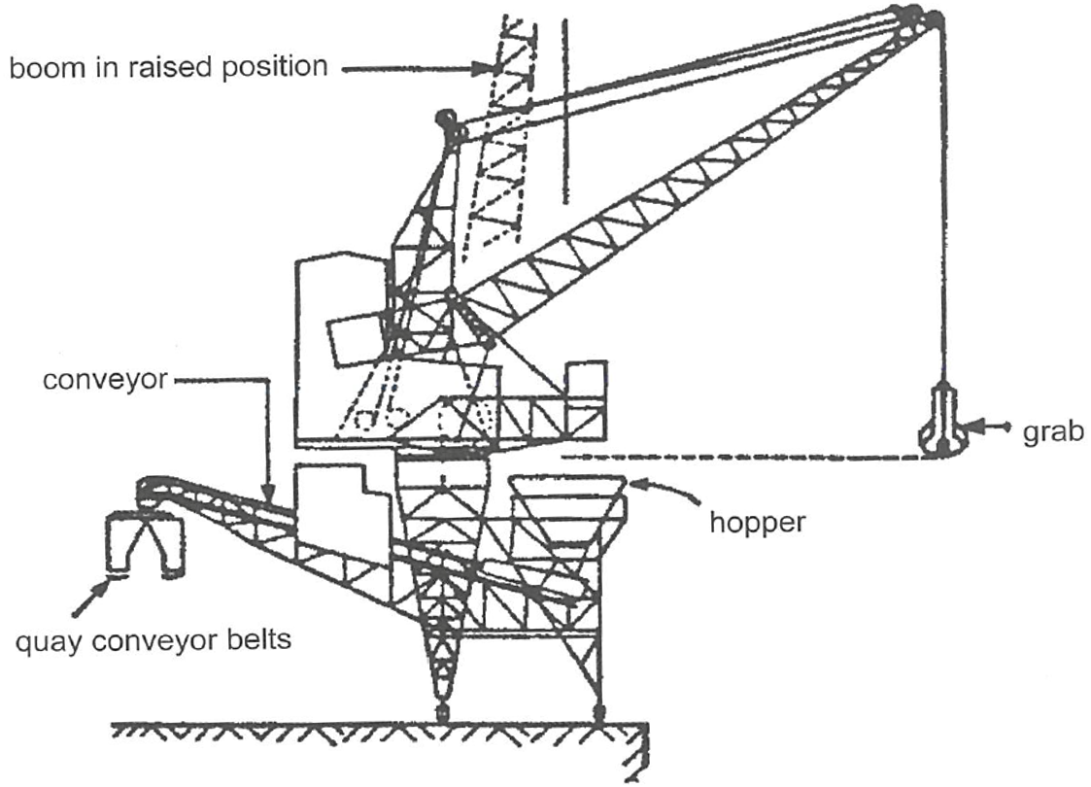

Figure 0.7: Radial grab

* + - * 1. Mobile Harbour Cranes

Generally used in smaller ports and comprises of a mobile crane with tower structure to allow the operator to view the hold during operations. **Handling rates are similar to that of revolving grabbing cranes**, however, as movement between holds takes longer than rail mounted radial cranes, the *Ship Unloading* Equipment is slightly lower (0.9 vs. 1.0). This is due to the fact that mobile harbor cranes have to resposition the operator cabin and lift and lower their outriggers at each move.

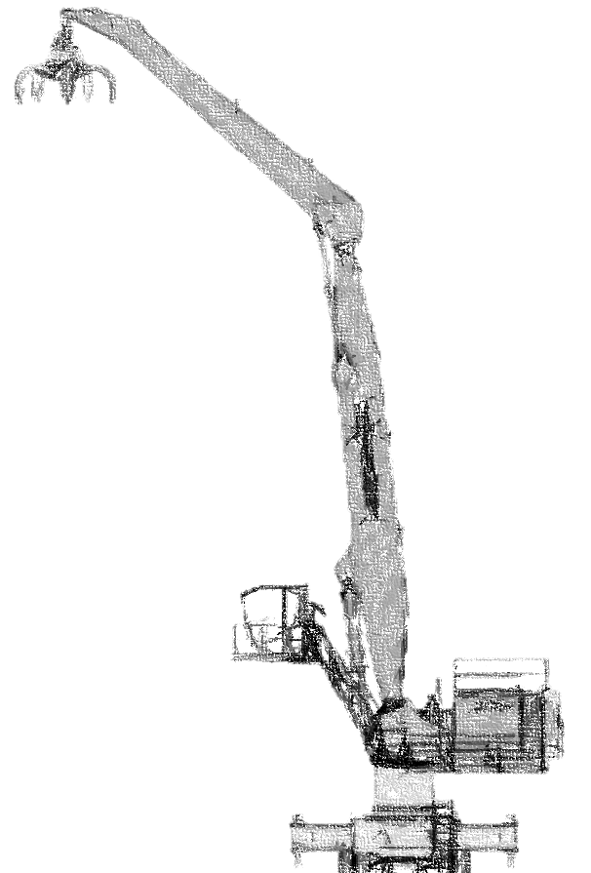

Figure 0.8: Mobile harbour crane

* + 1. Bucket Elevators

A bucket elevator (BU) is equipped with a L-shaped, bucket-elevator-type unloading device that is suspended from the BU’s boom. continuously unload a vessel via an extensive bucket chain. the BU transports the material to the top of the boom, where it is unloaded onto a belt conveyor and transported towards the quay. The entire L-shaped system can rotate 360°, allowing full access to the hold, reducing the time needed for trimming. It is assumed that this increases the *Ship Unloading* Equipment *index* to 1.2 (in contrast to 1.0 for grab cranes). The bucket elevator moves parallel to the vessel on pier-mounted rails.

According to literature (UNCTAD, 1985), there is a wide spread in the capacity of bucket elevators (e.g. 1000 – 5000 [t/h]). The unloading capacity of a bucket elevator within the model has therefore been benchmarked using bucket elevators produced by ThyssenKrupp, a German manuafacturer (**see figure X**). As a result of the benchmark, it is assumed that bucket elevators have a *free-digging* *capacity* between 650 and 2700 [m3/h].

Figure 0.9: Constructed bucket elevators (ThyssenKrupp, 2007)

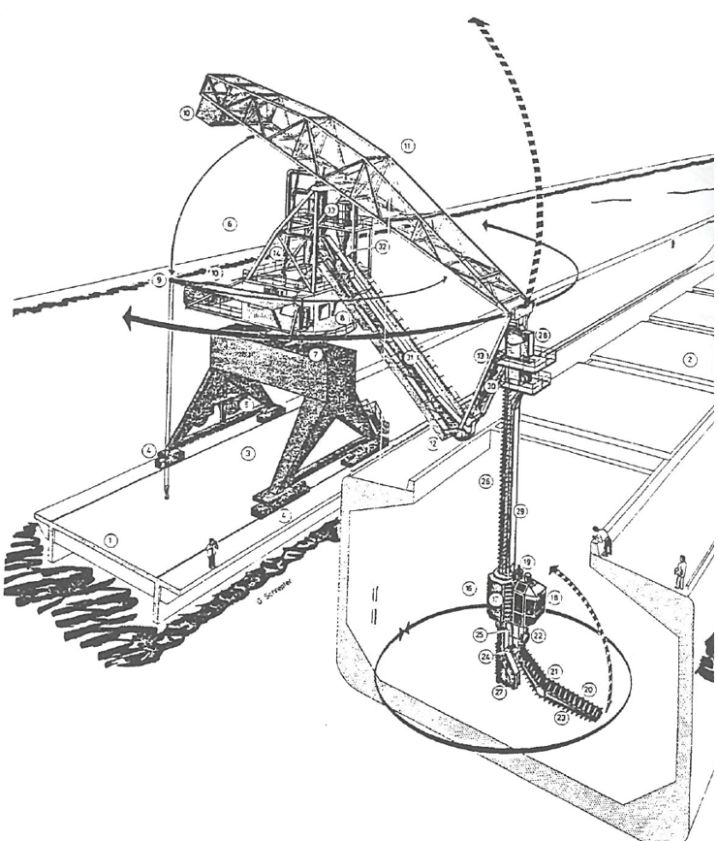

Figure 0.10: Bucket elevator

* + 1. Vertical Screw Ship Unloaders

Vertical screw ship unloaders feature Archimedean screw type elevators that discharge the cargo onto a slewing boom with a fully enclosed transfer conveyor. The elevator system may be ‘steered’ to improve access into the wings of the hold, even more so than that of the Bucket Elevators, reducing the time needed to trim the hold. It is therefore assumed that this increases the *Ship Unloading* Equipment *index* to 1.4 in contrast to grab cranes. However, vertical screw unloaders are only suitable for dry, free-flowing commodities. Discharge from this type of unloader may be directed to a quayside conveyor or directly onto trucks and rail wagons (PIANC, 2014).

The literature study into the capacity of these types of ship unloaders provides a wide range of unloading capacities. UNCTAD, dated from 1985, describe a maximum capacity of 600 [t/h] (UNCTAD, 1985), whereas modern rates go up to as much as 2400 [t/h] when handling coal (PIANC, 2014). This implies that there is a strong development within the production of screw unloaders.

|  |  |  |  |  |  |
| --- | --- | --- | --- | --- | --- |
| Terminal | Peak t/h | Rated t/h | Effective t/h | Weight (t) | Width (m) |
| Bunge | 700 | 450 |  |  |  |
| *Unknown* in Liverpool (transported by BigLift) | 1200 |  |  | 560 | 24 |

In order to provide an accurate assessment, unloading rates have been benchmarked using a range of vertical screw conveyors currently utilized by dry bulk terminals. Further information was provided by one of the global leading producers of vertical screw unloaders based in Sweden, Siwertell. **Figure x** visualizes how the *free-digging rate* of vertical screw excavators lies between 400 and 1950 [m3/h].

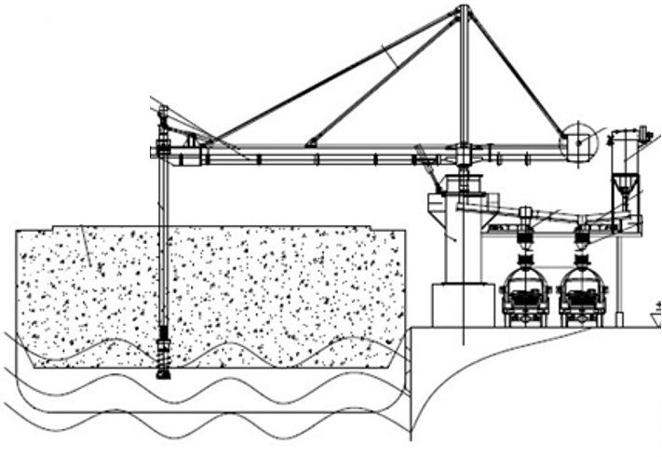

Figure 0.11: Vertical screw ship unloaders

|  |  |
| --- | --- |
| Source | Production |
| (UNCTAD, 1985) | 250 t/h (revolving) |
|  |  |
|  |  |
|  |  |

|  |  |  |  |
| --- | --- | --- | --- |
| Crane type | Cycles per hour | Peak capacity | Effective Capacity Index |
| Gantry grabs | 60 | $\frac{C_{crane}-2.41}{1.404}$ per cycle | 1.0 |
| Level-huffing grabs | 40 | $\frac{C_{crane}-2.41}{1.404}$ per cycle | 1.0 |
| Radial grabs | 20 | $\frac{C_{crane}-2.41}{1.404}$ per cycle | 1.0 |
| Mobile harbor crane | 20 | $\frac{C_{crane}-2.41}{1.404}$ per cycle | 0.9 |
| Vertical screw conveyor | - | Max 2400 t/h (coal) | 1.2 |
| Bucket Elevator | - | Max 5000 t/h (coal) | 1.2 |

#### Terminal storage

Introduction

* + 1. Storage Requirements
    2. Silo Storage

An alternative to covered storage, for free flowing, dry cargoes such as grain and animal

feed where protection is required not only against the weather but also against vermin, or

cargos such as cement where the material is particularly dusty, vertical silos can be used.

These are typically vertical circular silos arranged in multiple units and fed via conveyor to

the top of the silos and reclaimed from the base of the silos direct to a bagging plant, road

truck or rail wagon. Material is usually withdrawn from the silos by variable speed feeder

conveyors and may be directed onto other conveyors for transport to a ship loader or a

process plant. Cement and other fine dusty cargo is usually pumped into the silos and

withdrawn through pipes also.

(PIANC, 2014)

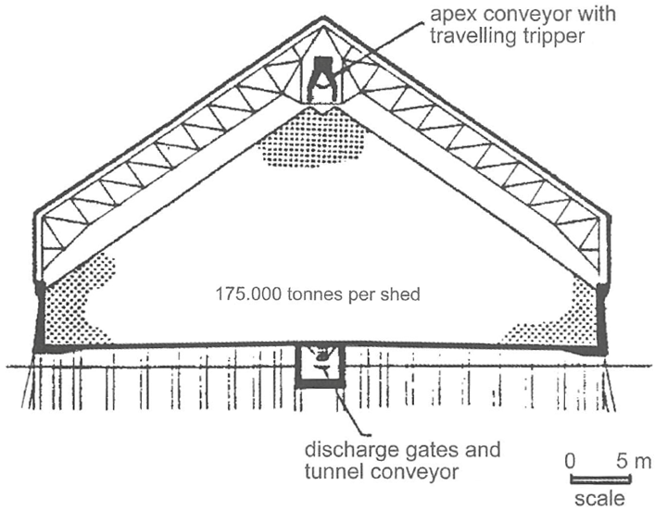

* + 1. Covered Storage

Bulk cargoes which require protection from the weather, or themselves pose significant

environmental risks require covered storage, normally a conventional portal framed

structure with the material being fed into the store via overhead conveyors with travelling

trippers and reclaimed by means of rail mounted travelling portal scraper reclaimers or

mobile plant. Some covered storage is in the form of geodesic dome structures that feature circular stackers and scraper reclaimers. (PIANC, 2014)

* + 1. Open Storage

#### Terminal landside interface

Model split?

For export terminals the delivery of bulk cargo to the export stockpile may be by rail, road

or some form of fixed conveying system such as overhead bucket conveyors. The most

usual method is by rail, with wagons emptied either by:

• Bottom discharge to an underground hopper feeding belt conveyors

• Rotary tipping to an underground hopper feeding belt conveyors

• End tipping to an underground hopper feeding belt conveyors

• Pneumatic discharge in the case of products such as cement in bulk

Discharge of road going vehicles is similar, but generally the vehicles are self-discharging,

i.e. tipper trucks, and frequently discharge to mobile hoppers to be carried by conveyor to

stockpiles/silos or to the feed hopper of mobile shiploaders for direct ship loading.

Similar considerations apply to import terminals, where the delivery of the bulk cargo, either

from the terminal stockyard or from the quayside, to the final destination may be by road,

rail, conveyor or a combination of these. For transfer to road or rail transport it may first be

necessary to reclaim materials from the stockpiles and transfer it to road or rail loading silos,

unless direct loading to the transport is contemplated. Direct loading operations of this sort

using mobile plant are inevitably less efficient and less environmentally acceptable, but may

provide the lowest overall cost solution. (PIANC, 2014)

* + 1. Ship Loading Equipment

Ship loading systems are relatively simple compared with unloading systems, since

generally only a simple feed conveyor and chute are needed to load the vessel. The

shiploaders are normally positioned adjacent to the hatch to be loaded and receive the

material via belt conveyors from the stockpile. These feed a loading boom which projects

from the berth face over the hold. Shiploaders with boom conveyors fall into three distinct

categories (PIANC, 2014):

**Rail Mounted Travelling Loaders** that move along the length of the vessel and are fed

from the loading pier conveyor up an inclined tripper section that lifts the conveyor to the

transfer point on the boom conveyor. These fall into two further sub categories that provide

the variable outreach:

• **Slewing Loaders** where a fixed length boom may be slewed into position, in

combination with long travel movements to reach all points of the hatch opening.

• **Boom Conveyor Shuttle Systems** that enable the discharge pulley of the loading

conveyor to move perpendicular to the beam of the vessel. The combination of shuttle

movement and long travelling provides the full hatch coverage required.

**Single or Dual Quadrant Loaders** that have one or two loading booms with a fixed pivot

point at the landward end. The outer end of the boom(s) travel in an arc on rails and a

shuttle system on the boom provides full hatch coverage.

**Dual Linear Shiploaders** where the waterside end of the loading boom travels on short

rails parallel with the length of the vessel and the landward end of the loading boom moves

at right angles to the berthing line. Full hatch coverage is again provided by a shuttle system.

All three types should also incorporate a luffing motion to accommodate tidal changes and

the changing draught of the vessel as it is loaded.

Currently the highest rated shiploaders in service loading iron ore range from 16-18,000 tonnes per hour. The effective loading rates are heavily influenced by the performance of the equipment used to reclaim material from the stockpiles – usually bucket wheel reclaimers in the case of coal and iron ore. (PIANC, 2014)

#### Environmental aspects

(Wiegmans & Schott, 2017)



Safety zones

Dust hazard

#### Terminal example

adsfasdf

# Optimizing Terminal Design Strategy



## Literature Study Into Terminal Modelling

#### Existing terminal models

(Wiegmans & Schott, 2017)

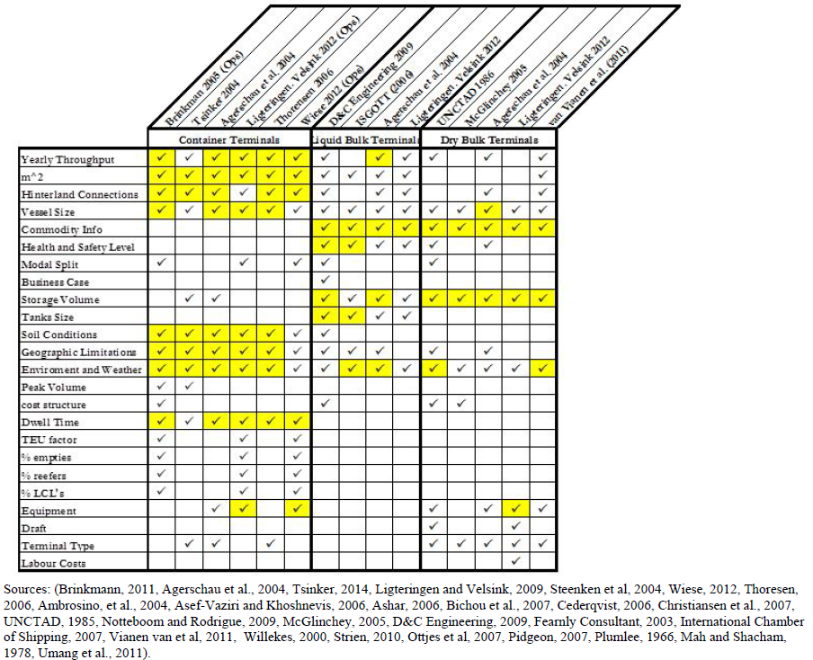

#### Simulating terminal seaside interface

Sdfasdf

#### Simulating terminal superstructure

sdfasdf

#### Simulating terminal landside interface

Sdfasdf

Asd

Teun vna Vianen et al.

“

Modeling the seaside operation is essential for realizing realistic quay designs. Compared to the significant amount of research on the transshipment of containers at container terminals, a limited number of papers discussed the seaside operation at dry bulk terminals. The seaside modeling of container terminals will be investigated to find possible analogies that can be applied to dry bulk terminals. Comprehensive overviews on applications and optimization models for the operations management in container terminals were given by Vis and De Koster (2003), Stahlbock and Voβ (2008) and Bierwirth and Meisel (2010). Several sub problems were distinguished; the assignment of ships to berthing locations alongside the quay (the berth allocation problem), the assignment of cranes to ships (the quay crane assignment problem) and the determination of cranes operating plans (the quay crane scheduling problem). Sections 3.3.1 until 3.3.3 review the literature available for these sub problems and section 3.3.4 evaluates this survey and indicates the approach used in this chapter.

**3.3.1 Berth Allocation Problem**

The berth allocation problem covers the mooring of a set of ships within the boundaries of the quay and within the planning horizon. For each ship additional data like the ship’s length, its draft, the expected time of arrival, and the projected handling time must be given. Several spatial constraints restrict the feasible berthing positions according to a preset partitioning of the quay into berths.

According to Imai et al. (2005) the following layouts can be recognized:

• Discrete quay layout (Figure 3.7A): the quay is divided into a number of berths and only one vessel can be served at each single berth. Either the quay construction causes the partitioning into berths or berths are applied to ease the planning problem.

• Continuous quay layout (Figure 3.7B): the quay has no spatial constraints and vessels can berth at arbitrary positions. Berth planning is more complicated but the quay can better be utilized.

• Hybrid quay layout (Figure 3.7C): the quay is partitioned into berths but large vessels may occupy more than one berth and small vessels may share a berth.

Han et al. (2006) and Zhou et al. (2006) included spatial constraints into their models to ensure that ships are moored at positions with sufficient water depth. Many models were developed to minimize the sum of the ships waiting and handling times. Schonfeld and Frank (1984) employed analytical models, Lai and Shih (1992), Legato and Mazza (2001 and 2013), Henesey et al. (2004) and Canonaco et al. (2008) developed simulation models and Dragovic et al. (2006) developed an analytical model based on queuing theory. 30 Simulation-integrated design of dry bulk terminals

Many authors suggested the First-Come-First-Served (FCFS) method to determine the ship service order; Lai and Shih (1992), Botter et al. (2005), Singh et al. (2010), Hartmann et al. (2011) and Umang et al. (2013). The Earliest-Due-Date (EDD) method when ships with the earliest due date for completion are firstly berthed was suggested by Lai and Shih (1992) and Hartmann et al. (2011). Barros et al. (2011) proposed a high demurrage ship algorithm for the ship service order. The demurrage cost for each arrived ship must be calculated. The total terminal cost can then be minimized by serving high-cost ships earlier than low-cost ones.

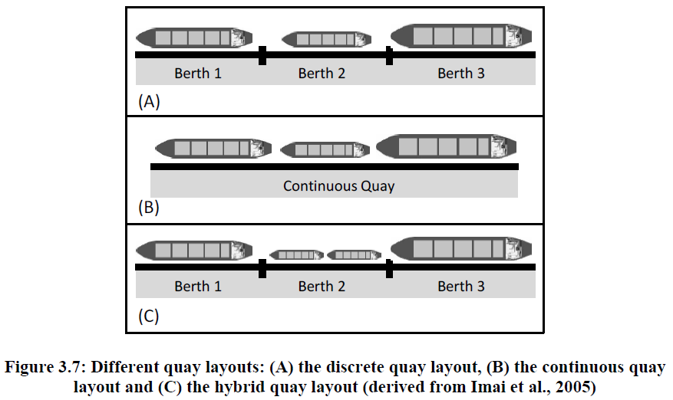

Umang et al. (2013) and Robenek et al. (2013) studied the berth allocation problem explicitly for bulk ports by taking the cargo type (liquid bulk and dry bulk) into account. Conveyors or pipelines have to be selected for the transport of cargo between the seaside and predefined stockyard locations. In both papers it was assumed that the entire shipload was stored at one location. The authors stated that solving the problem for multiple storage locations per ship would be complicated. Two exact methods based on mixed integer linear programming were proposed. Heuristic approaches based on squeaky wheel optimization (Umang et al., 2013) and critical-shaking neighborhood search (Robenek et al., 2013) were applied to solve the problem in large scale environments.

## Optimization Through Simulation

Introduction

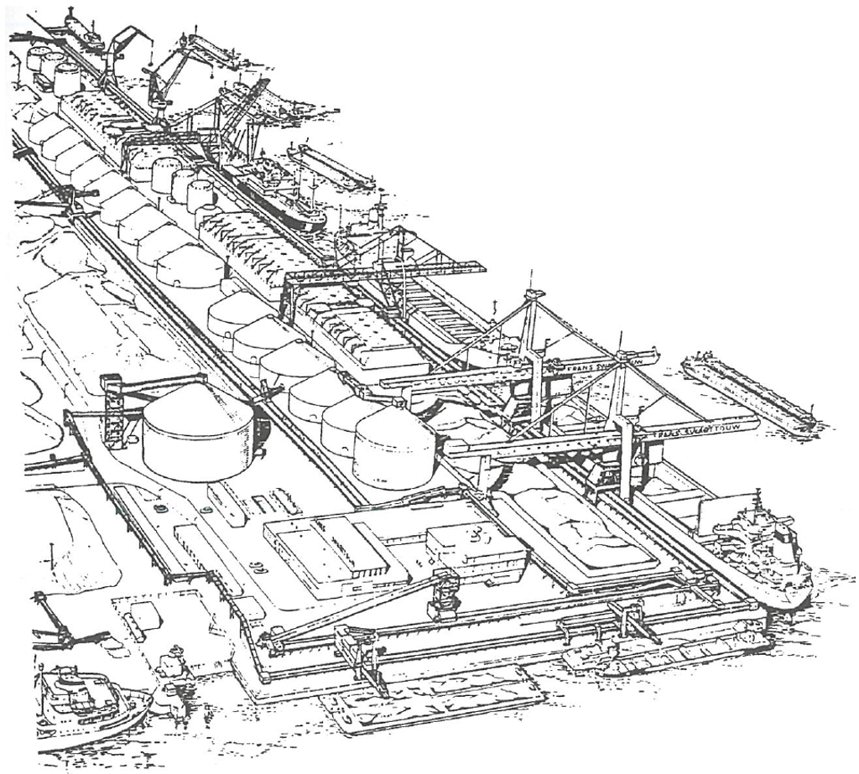

A distinct feature of optimization programming in general is the exponential relationship between the number of optimization variables and the model’s computational requirements. It is therefore useful to conduct a preliminary sensitivity analysis on the impact of different terminal elements on the overall lifetime cost of a project. The goal of the sensitivity analysis is to determine what elements should essentially be included in the optimization algorithm (i.e. the elements that have a large impact on overall terminal life-cycle costs). Once the capital-intensive elements have been optimized, the remaining terminal elements will be geared to meet hourly unloading capacity.

#### Modelling objective

Asdasd

#### Key performance indicators

Asdfasdf

Asdasd

Asd

#### Model structure

Responsive vs predictive

* + 1. Model input

Based on economic scenario’s

* + 1. Model output

Invrestment trigger optimimalisation

#### Triggering investments within the simulation

* + 1. Literature review

Berth allocation problem

Quay crane assignment problem

Evalutation of modelling approaches

#### Significant factors for terminal design

#### Increasing terminal flexibility

## Making Economic Projections

Introduction

#### Traffic scenario’s

sdfasdf

**“The proposed forecast methodology**

At the start of this PhD project a method for developing probabilistic very long term transport forecasts with a time span of almost 100 years did not yet exist. I have therefore developed a new probabilistic forecast method that is based on the existence of a strong causal relation between economic output and transport. This new method contains the following three steps: (1) apply system dynamics modelling to obtain a probabilistic forecast of the total- and working age population in the Region; (2) apply judgement to make probabilistic assumptions on the development of labour participation, annual working hours, and GDP output per worker – and use these assumptions to convert the probabilistic estimates of the working age population into a probabilistic GDP forecast for the Region; and (3) apply the causal GDP-transport relation to obtain a probabilistic transport forecast for the Region.”

“However, the simultaneous upward movement of two trending time series does not necessarily imply that a real causal relation between these two variables exists. To make sure that the GDP-transport relation is real I studied the special case of Lithuania, for which the economy has been growing until the dissolution of the USSR in 1989, showed a decline thereafter, and recovered from 1995 onwards. The data for Lithuania showed a simultaneous movement of the GDP and transport variables along an up- and downward trend and therefore ‘proved’ that the causal relation between GDP and transport is real – and if this holds for the single country of Lithuania it is also likely to hold in general (see Figure 7-2).”

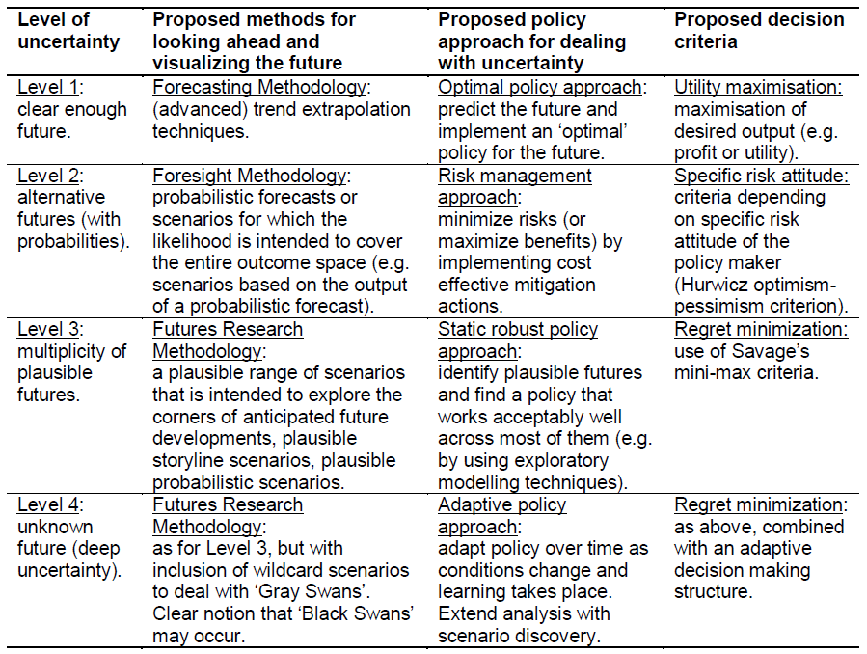

#### Traffic forcasting

Scenario’s developed for the investment simulator based on UN population growth, and GDP per capita development. Includes erratic

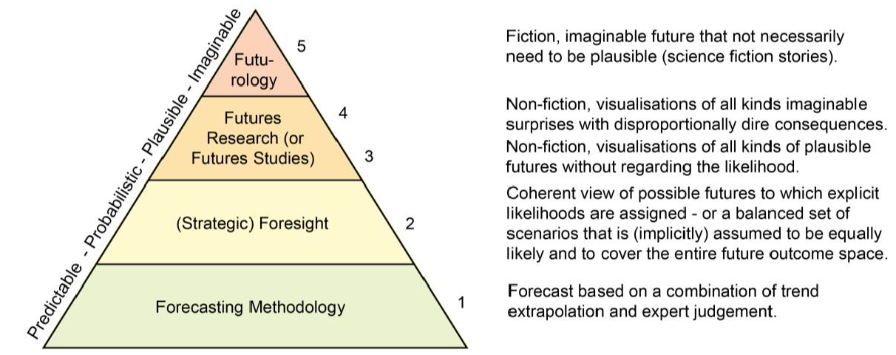

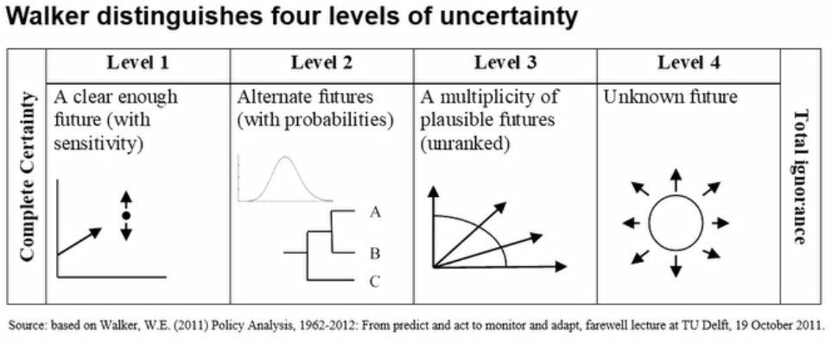

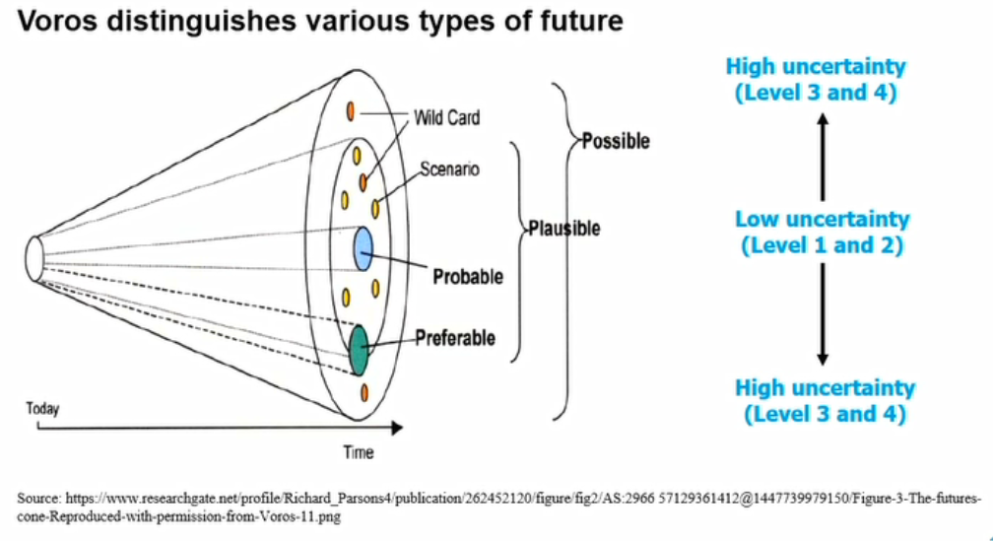

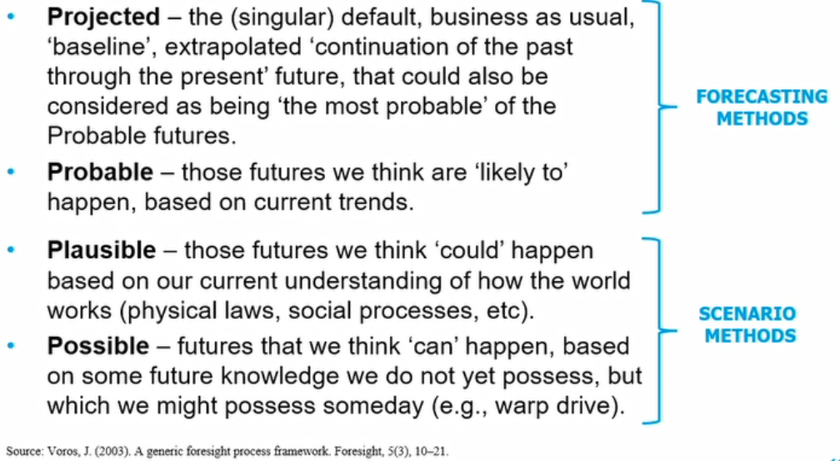

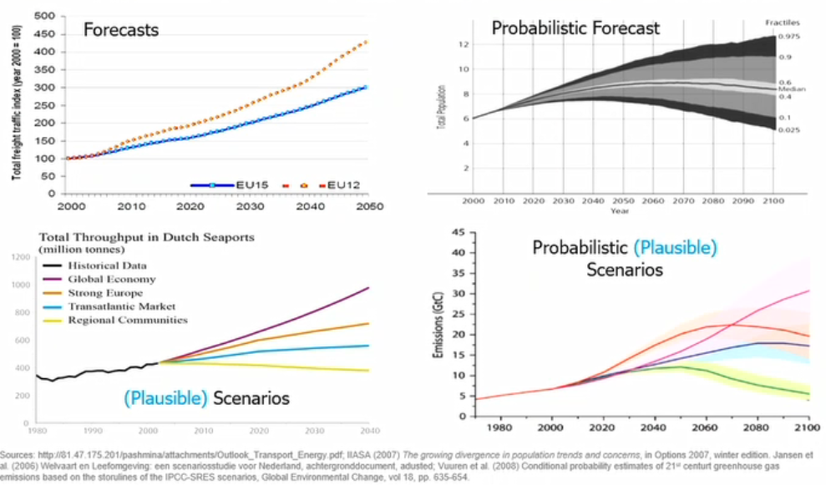

* + 1. Two Distinctive Port Layouts

High capacity conveyer systems linked to storage. Or unloaders load into trucks and is brought to storage.

#### Application within the model

## Reactive simulation approach

Introduction

#### Applied economic projection methods

Sdfasdf

#### Terminal seaside interface

Sdfasdf

#### Terminal superstructure

sdfasdf

#### Terminal landside interface

Sdfasdf

Asd

## Predictive simulation approach

Introduction

#### Applied economic projection methods

Sdfasdf

#### Terminal seaside interface

Sdfasdf

#### Terminal superstructure

sdfasdf

#### Terminal landside interface

sdfasdf

asdas

## Results

Introduction

#### Reactive approach

Name goal of approach

* + 1. Investment trigger assessment

Sdfasdf

#### Predictive approach

Name goal of approach

* + 1. Investment trigger assessment

Sdfasdf

* + 1. Forcast window assessment

Sdfasdf



# Case Study

## Agribulk Import Terminal in Africa

Introduction

#### Why Africa?

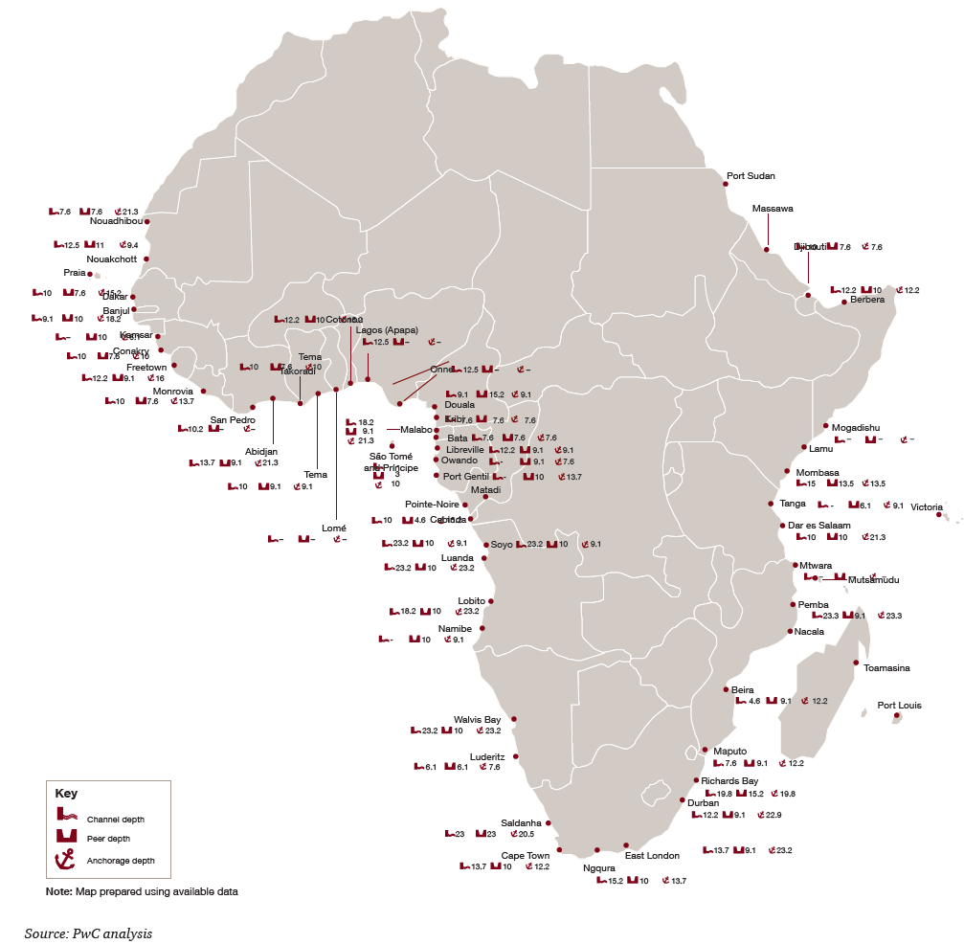

Figure 0.1: Berthing Depths in African Port (PWC, 2018)

#### Terminal location

Name goal of approach

#### Applied economic projections

Asdfasdf

* + 1. Traffic scenario’s

Asdfasdf

* + 1. Forcasting method

Asdfasdf

* + - 1. Forcast window

Asdfasdf

#### Resulting terminal

Asdfasdf

#### Conclusions

Asdfasdf

# Conclusions and Recommendations



## Conclusions

Introduction

#### Research into investment triggers

asdfdasf

#### The added value of integrating forcasting into the design process

asdfafd

## Recommendations

Introduction

#### Investment triggers

asdfdasf

#### Forcasting mechanism

asdfafd

asdfas

## Appendix – Model Validation

Introduction

#### Investment triggers

asdfdasf

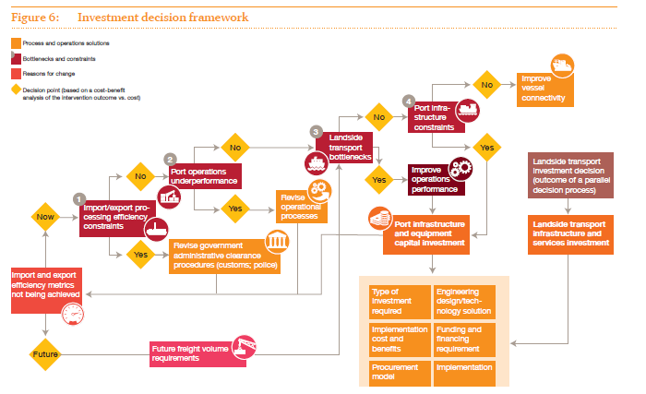

Figure 0.1: Port Optimization Cycle (PWC, 2018)

## Bibliography

Bart-Plange, A., Dzisi, A., & Addo, A. (2011). A Comparative Study of Some Physical Properties of Large and Medium Size Cocoa Beans from Ghana, *2*(3), 135–141. Retrieved from http://www.ejournalofscience.org/archive/vol2no3/vol2no3_2.pdf

Dragović, B., Tzannatos, E., & Park, N. K. (2017). Simulation modelling in ports and container terminals: literature overview and analysis by research field, application area and tool. *Flexible Services and Manufacturing Journal*, *29*(1), 4–34. https://doi.org/10.1007/s10696-016-9239-5

Dunlop, F. (2009). *Conveyor Handbook*.

Ligteringen, H., & Velsink, H. (2017). *Ports and Terminals* (Second). Delft Academic Press.

Miedema, S. A. (2006). A Sensitivity Analysis of the Production of Clamshells, 181–200.

Nemag. (2018). The Clamshell Grab. Retrieved from https://www.nemag.com/uploads/2017/06/Productbrochure-clamshellgrab-EN.pdf

Omega. (2015). Material characteristic guide.

PIANC. (2014). *Report n° 158 - 2014 Masterplans for the development of existing ports*.

PPI. (2009). Idler Selection Guide, 1–13.

PWC. (2018). *Strengthening Africa’s gateways to trade*.

RoKulinowski, P., & Kasza, P. (2011). Belt Conveyors for Bulk Materials Calculations.

Schulze, D. (2008). *Powders and Bulk Solids*.

ThyssenKrupp. (2007). Continuous Ship Unloaders, 1–6.

UNCTAD. (1985). *Port Development: A Handbook For Planners In Developing Countries*. https://doi.org/10.1007/978-1-84882-997-8_16

University of Georgia. (2016). Density of agricultural products. Retrieved from http://www.caes.uga.edu/departments/bae/extension/handbook/documents/Density of Agricultural Products.pdf

Verschoof, I. J. (2002). Cranes, Design Practice and Maintenance. *Professional Engineering Publishing*, *2nd Editio*.

Verstegen. (2018). Bulk handling grabs - Verstegen. Retrieved April 25, 2018, from https://www.verstegen.net/grabs/

Wang, Y., Chung, D. O. S. U. P., & Spillman, C. K. (1995). Physical Properties of Soybean Meal, *72*(6), 523–526.

Wiegmans, B., & Schott, D. (2017). ScienceDirect Incorporating commodity flexibility in terminal design : Strategies to change commodities at a terminal, *00*(July 2016).

Wu, M.-R. (2012). *A Large-Scale Biomass Bulk Terminal*.

The Pearl in the Shell  
Unlocking Value in the   
Maritime & Transport Industry

Maritime & Transport Business Solutions

|  |  |  |
| --- | --- | --- |
| **address** |  | Wijnhaven 3E |
|  |  | P.O. BOX 601 |
|  |  | 3011 WG Rotterdam  The Netherlands |
| **telephone** |  | +31 (0)10 286 59 40 |
| **e-mail** |  | info@mtbs.nl |
| **internet** |  | www.mtbs.nl |

